Report on Special Assistance at Belfast International Airport

May 2022
Contents

1. EXECUTIVE SUMMARY 2
2. INTRODUCTION 2
3. METHODOLOGY 4
4. FINDINGS 4
5. CONCLUSIONS 22
6. NEXT STEPS 23
Annex 1 Summary of Recommendations 24

1. EXECUTIVE SUMMARY

1.1 European Regulation (EC) 1107/2006 (the Regulation) provides rights for passengers with disabilities and reduced mobility when travelling by air. This has been retained in United Kingdom (UK) law following the UK’s exit from the European Union (EU).

1.2 The Regulation requires all airports and airlines in the UK and EU to provide assistance to passengers with a disability or reduced mobility. The Consumer Council has been designated by the Civil Aviation Authority (CAA) to be the complaints handling body for the Regulation.

1.3 In 2014 the CAA issued guidance requiring airports to consult with passengers with a disability or reduced mobility. This report details the findings of a meeting on 15 March 2022 of the Belfast International Airport’s Accessibility Forum which involved a tour of the airport building. The Forum is made up of a range of organisations which represent consumers with a disability or reduced mobility.

1.4 The Forum was positive about the airport’s facilities and, in particular, the special assistance services that are provided to passengers right through from the initial car park call points to departures. There were a number of suggestions made by participants. These focussed on:
- Signage;
- Flight Display Boards;
- Colour contrasting on escalators/steps;
- Wheelchair access;
- Toilet facilities.

1.5 The findings of the visit will be shared with the airport. An update on progress made against the recommendations will be reported by the airport to the Accessibility Forum at its next meeting.

2. INTRODUCTION

2.1 In 2006 European Regulations came into place that require all airports and airlines in the EU to assist passengers with a disability or with a reduced mobility (PRM) when travelling. These have been retained and written in UK law since its exit from the EU. Airlines licensed in the EU, operating flights from a non-EU country into the EU must also assist passengers.

2.2 The Consumer Council has been designated by the CAA as the complaints handling body for the Regulation relating to an airport in Northern Ireland or a flight departing from a Northern Ireland airport. The Consumer Council works alongside the Northern Ireland airports to ensure that their services continue to meet passengers’ needs.

2.3 In 2014 the CAA issued guidance requiring airports to consult with passengers with a disability or reduced mobility. This ‘should, as much as possible, include practical inspections of airport services (generally using ‘walk throughs’). Airports should also consider convening regular forums containing representatives of disability groups and individuals’

2.4 In 2019, the Consumer Council worked with Belfast International Airport to establish an Accessibility Forum at the airport. Membership of the Accessibility Forum consists of a range of organisations that represent consumers with a disability or reduced mobility. The aim is to provide a forum for users of the Airport’s Special Assistance services or their representatives to share their knowledge and experiences of services at the airport.

2.5 The first meeting of the Accessibility Forum took place on 7 February 2019 and involved a tour of the airport facilities. Forum members provided feedback on the facilities and services and identified possible changes that could further assist air passengers with a disability or reduced mobility. The airport has since implemented a number of recommendations made by participants on the day.

2.6 Due to Covid-19 restrictions, no meeting of the Accessibility Forum took place in 2020.

2.7 The intended outcome of this visit is for the Forum to continue to work with the airport in looking specifically at special assistance to gain a better understanding of issues faced by passengers using this service. In particular, it is intended to identify areas where it works well, and to implement suggestions made by forum members to help make travel more convenient for those passengers. The airport will provide feedback on actions taken from the recommendations made at the next forum meeting.

2.8 Belfast International Airport and the Consumer Council would like to thank those participants who took part on the day.

3. METHODOLOGY

3.1 The Forum met at the airport on 15 March 2022. There were eight participants from a range of organisations that represent consumers with a disability or reduced mobility.

3.2 The Forum began with an introduction from the Consumer Council and airport. A member of the airport’s car park staff then talked members through the process for passengers wishing to park at the airport. The Consumer Council and airport staff then guided the group through the airport, beginning at the check-in area and finishing in the arrivals areas. A brief round-up discussion with the whole Forum was held at the end of the tour.

3.3 Staff from the Consumer Council took notes at the visit and recorded the suggestions that were made by the group.

4. FINDINGS

4.1 The following section provides a summary of the key discussion points that were recorded with corresponding recommendations. The findings are set out in the order of the various stages of moving through the airport, with an overall summary provided at Annex 1.

Arrival at the airport/parking area

4.2 Disabled parking bays are available in the short stay car park but participants commented that this was not very visible or easy to find when driving in and that clearer signage would assist.

4.3 The airport informed the group of the five stage process for booking car parking that allows blue badge holders to avail of car parking in the short stay car park at the cheapest car parking rate; either by letting the airport know in advance or by pressing the “help” button so that they were not charged at full rate if staying over one hour. The same service also applied to those with reduced mobility but not in possession of a blue badge, provided they pressed the “help” button at the pay station and explained their situation. Many of the participants were not aware that this facility was available.

4.4 A participant noted that the accessible car parking spaces were quite narrow for wheelchair users to navigate. Airport staff said that these had been audited and were found to be of standard size and compliant with regulations.

4.5 Participants welcomed the fact that a temporary blue badge could be obtained for parking purposes, allowing passengers to travel with the original. It was also noted that drop offs were possible in the coach park with one disabled bay available, with the fee reduced to £1 for blue badge holders or others requiring special assistance so long as their situation was explained via the “help” button at the pay station.

Recommendations:

- Provide additional signage at entry to short stay car park with directions to disabled parking bays.
- Review the size of disabled parking bays and consider expanding beyond the regulation standard if possible.
- Ensure that the five stage process for booking car parking is easily accessible on the airport website.
- Provide additional information at pay stations so that passengers know they can avail of special assistance for parking.
- Make signage clearer around the accessible drop off areas to deter other vehicles from stopping there.
- Give consideration to increasing the amount of disabled parking bays in the coach park.

4.6 The airport staff emphasised the importance of booking special assistance with the airline at the time of booking. Although not related to the audit, airport staff noted an issue with the easyJet app, which did not follow through with special assistance requests – passengers needed to use a desktop device to make such bookings. The Consumer Council will follow this up with easyJet.
Check-in area

4.7 Participants noted that the Special Assistance desk was clearly signposted at the entrance to the check-in area (Figure 1). Other signage in this area was generally clear and at eye level, with good contrasting colours (black on yellow). The signage for reserved seating in the special assistance area was, however, found to be very small (Figure 2).

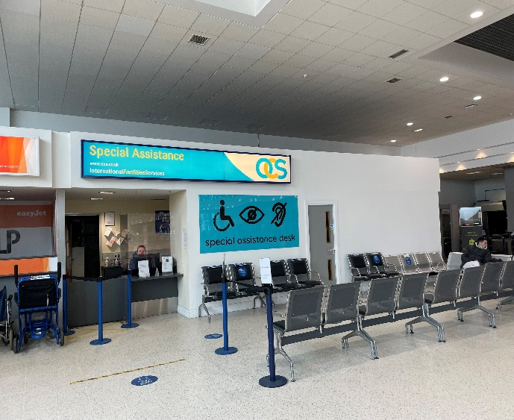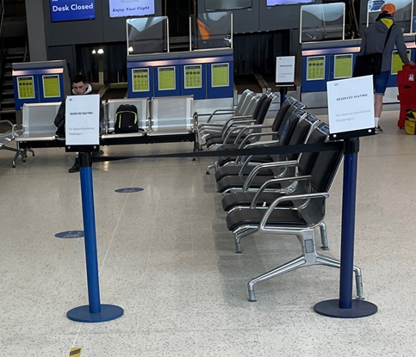
Figure 1: Special Assistance desk Figure 2: Reserved seating

Recommendation:

- Increase size of signage to reserved seating in the check-in area.

4.8 The toilets were clearly signposted from the check-in area; however corridors to the cubicles are very dark and could benefit from arrows at eye level (Figure 3). There is no changing places toilet at check-in level but there is one in the departures area upstairs after security. The disabled toilet provided a very narrow space for wheelchair users; also a handle to flush would be preferable to push button. Braille and “not every disability is hidden” signage should be provided here as it is for toilets located elsewhere in the airport (Figure 4).

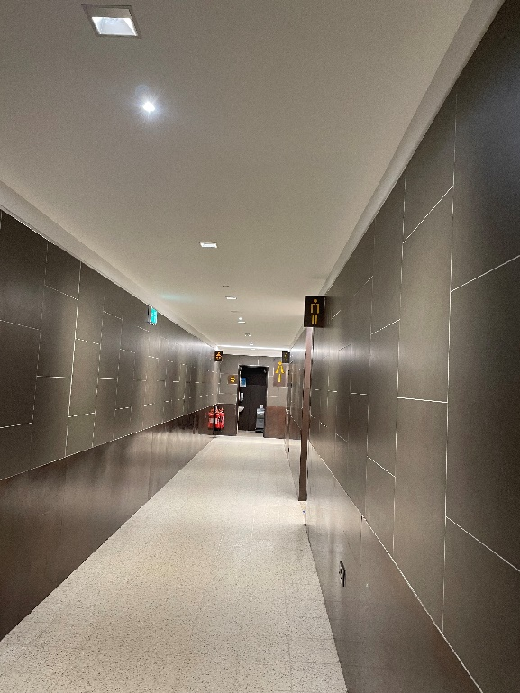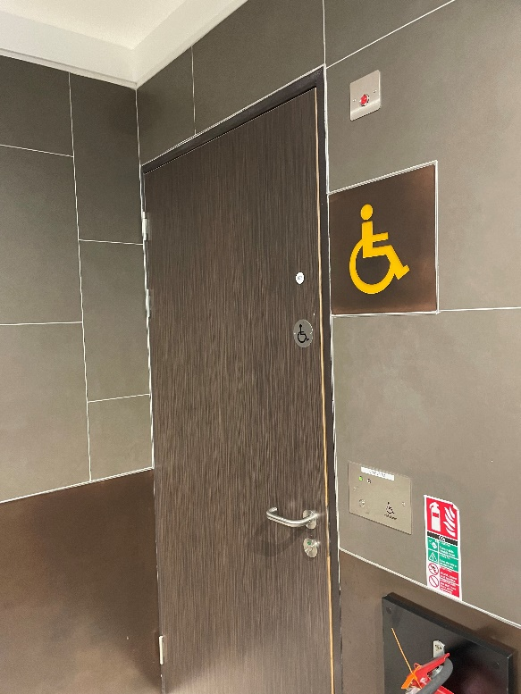
Figure 3: Corridor to toilets at check in Figure 4: Disabled toilet at check in

Recommendations:

- Provide additional signage e.g. arrows at eye level in toilet corridors.
- Provide signage to indicate presence of changing places toilet in departures area.
- Investigate possibility of installing an additional changing places toilet at check in area.
- Provide braille/”hidden disabilities” signage at disabled toilet.
- Investigate design of disabled toilet i.e. could more room be provided for wheelchair users.
- Investigate whether push button flush could be replaced with a handle.

Security
4.9 Participants noted that the top and bottom of the escalator up to the security area should be highlighted to let people with sight loss know that they are coming to the end of a moving walkway. Whilst there are lifts available, it is important that choice is offered where possible.
Recommendation:
- Place yellow strips at top and bottom of escalator.
4.10 Participants felt that signage to the priority/special assistance lane in the security area could be clearer (Figure 5). This area will be completely renovated as part of the new extension to the airport in 2023, so advertising signage in this area was temporary. Participants noted that overall there was not an “overload” of information on the walls in this area and felt it was important to ensure this was reflected in the new design.
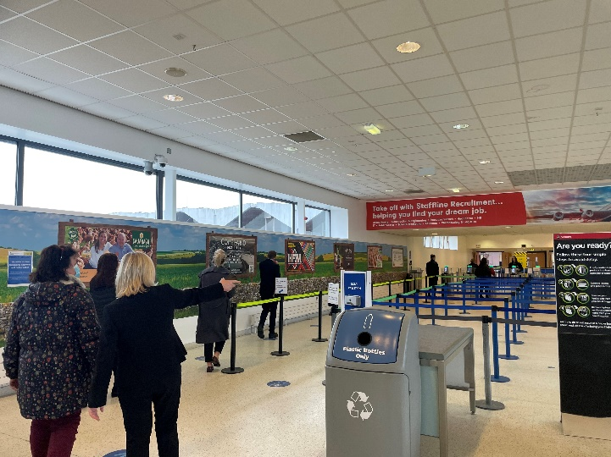
Figure 5: Priority/Special Assistance Lane
Recommendation:
- Make signage indicating priority/special assistance lane larger.
4.11 As passengers pass the ID/boarding card check, there is a small flight departures screen in the area heading towards security (Figure 6). Airport staff noted that larger screens were available in the departures lounge.
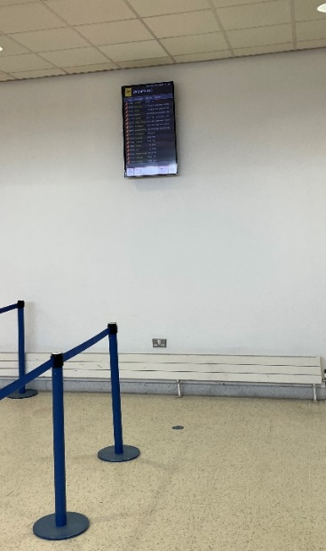
Figure 6: Screen in security area
Recommendation:
- Consider fitting a larger screen in the security area.
4.12 Once in the main security/bag check area, the priority lane was not immediately apparent as there was no contrast to the other aisles (Figure 7). It would be helpful if all the queue poles and ropes were in a contrasting colour to the floor – this would also aid staff in directing passengers to the queue.
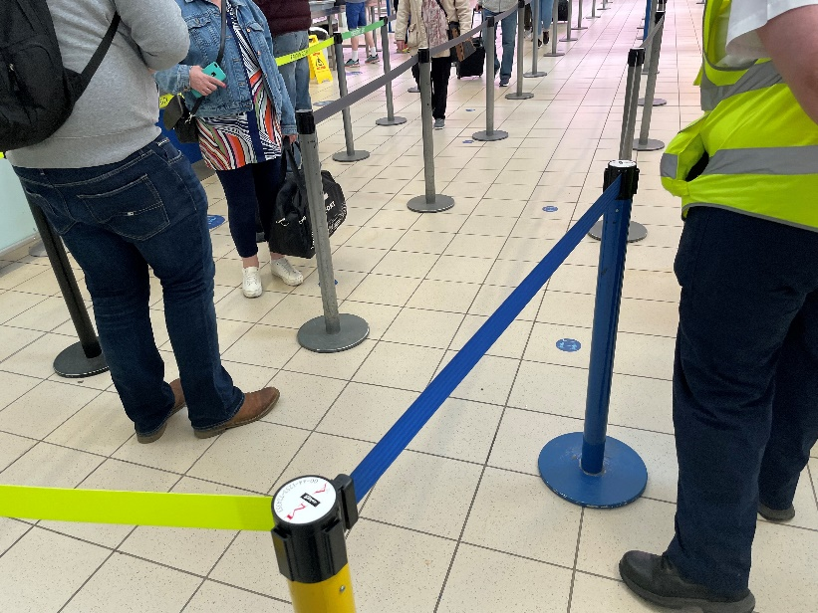
Figure 7: Priority/security queue in bag check area
Recommendation:
- Mark out priority queue clearly with one, contrasting colour for the poles and ropes e.g. yellow or blue.
4.13 A private search/interview room is available. However the area was carpeted which may not be easily navigated on a wheelchair.
Recommendation:
- Replace carpeted areas in the private search/interview room and in other areas of the airport with tiled/smooth flooring where possible.
4.14 It was noted that, whilst there are no specific dedicated toileting area for guide/assistance dogs, there is a procedure for airport staff to take them outside when necessary. The Guide Dogs NI participant stated that, in general, guide dogs are trained not to use grass, and agreed to share information with the airport as to best practice in this respect.
Action:
- BIA to liaise with Guide Dogs NI
Departures area
4.15 Once through security, passengers walk past a restaurant area. Airport staff noted that these were owned by third party organisations but that staff would have received training in disability awareness.
4.16 Participants commented positively on the size and contrast of the signage for the toilets immediately after the restaurant area (Figure 8), however they would benefit from additional textual signs. “Hidden disabilities” and braille signage on the disabled toilet were also noted. However it was considered that there was a very narrow entry for wheelchairs, as well as a “push button” system for flushing rather than a handle, which may be difficult for some users. Additional signage was required for the other toilet cubicles as the doors looked like a brown wall and were difficult to open.
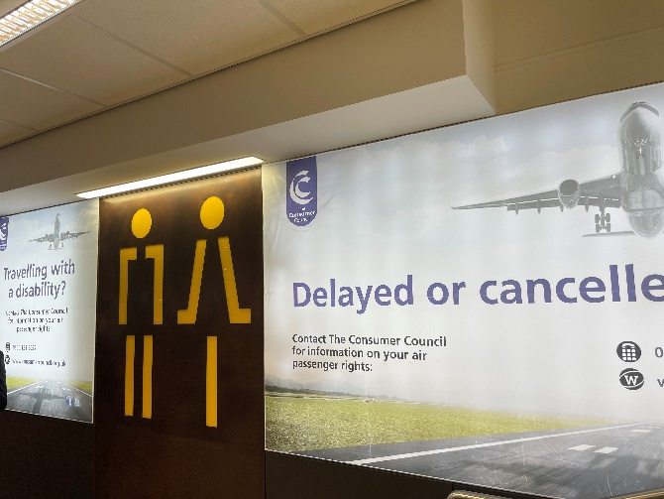
Figure 8: Toilets immediately after departures
Recommendations:
- Add additional textual “toilet” signage.
- Check configuration of disabled toilet to ensure there is enough space for wheelchairs.
- Consider installing an additional changing places toilet.
- Consider changing “push button” flush to handle in disabled toilet.
- Consider installing automatic “toilet protectors” in the disabled toilet to ensure users can easily disinfect the seat.
- Provide additional signage in main toilet areas to distinguish cubicles.
- Provide additional signage for hand dryers.
4.17 Participants praised the yellow strips at the top and bottom of the steps leading to the main departure area (Figure 9) and agreed that stairs throughout the airport should be marked in a similar way.
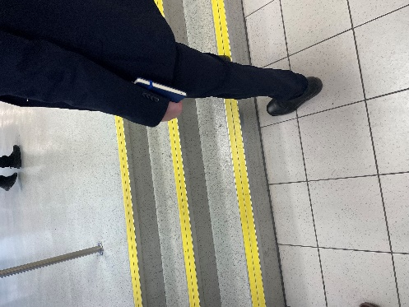
Figure 9: Steps to main departure area

4.18 There is a small amount of reserved seating in the departures area immediately after security (Figures 10 and 11). However, participants felt that is was not clearly marked out.
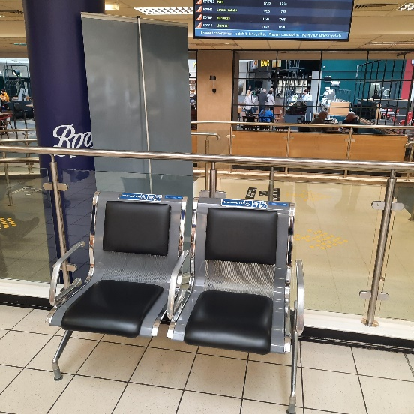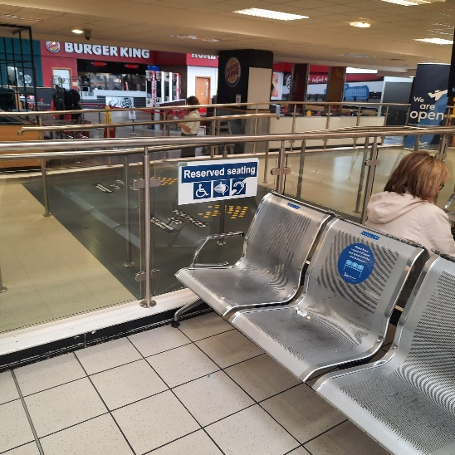
Figure 10 and 11: Reserved seating in departure area
Recommendation:
- Improve signage on reserved seating area e.g. mark in yellow to differentiate.
4.19 Participants noted white and black flooring in the departures area (Figure 12). This could cause issues particularly to people with dementia or autism, making them reluctant to cross as they may think there is a hole or a step up. In addition, a matt finish is preferable to gloss. Whilst there was no specific recommendation to make changes on this occasion, this should be noted for the future redesign.
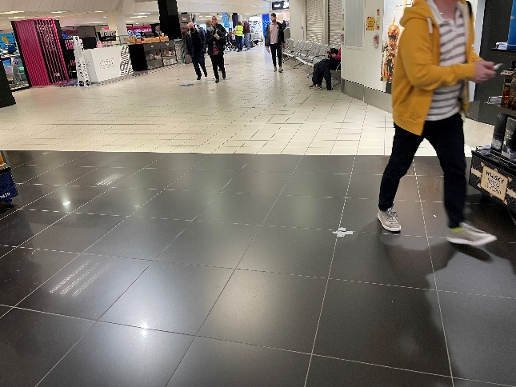
Figure 12: Flooring in departures area
4.20 One participant praised the airport’s approach to people with autism. For example there are signs on till points to indicate assistance for those with sensory requirements, and music can be lowered if requested. In addition, there is a specific section on the airport’s website to help children with autism plan their trip.
4.21 The signage with directions to gates were all positioned high on the ceiling which caused some confusion for participants particularly with regards to Gates 10 to 17, which required turning left rather than walking straight ahead (Figure 13). Some gates had directions indicated in large circles on the floor, which participants agreed worked well (Figure 14).
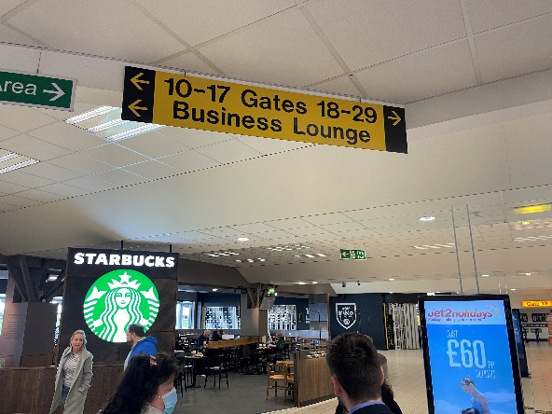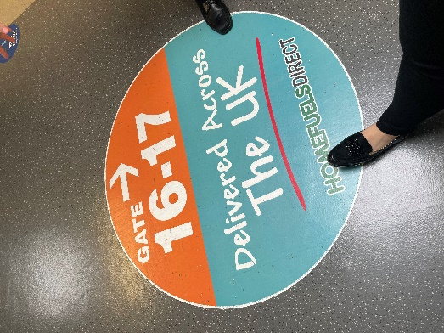
Figure 13: Directional signage in departure lounge Figure 14: On-floor signage
Recommendation:
- Provide additional directional signage to gates at eye level where possible and/or on floor where this is possible.
4.22 Participants continued into the departure areas for Gates 10-17. Staff explained that VINCI, the owners of the airport, had recently updated branding on signage to a green and brown colouring. Participants agreed that these colours were not good for accessibility purposes, contrasting colours such as blue and yellow work better. Whilst acknowledging that this was out of airport staff’s hands, participants did express disappointment and stressed that consultation with relevant groups prior to making such decisions was vital. The small signage to some gates was also noted (Figure 15).
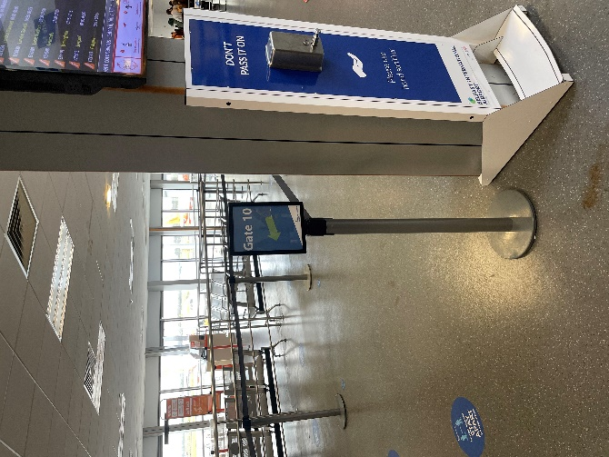
Figure 15: Gate 10 signage
Recommendations:
- Brown/green colouring on signage is problematic for accessibility purposes as it is more difficult to perceive information than other backgrounds e.g. black on yellow. This should be raised with the airport owners.
- Make signage indicating Gate 10 (and similar gates across the airport where applicable) larger.
4.23 During the visit participants witnessed the ambulift in action to board a passenger with reduced mobility onto a plane. Staff explained that the airport also has an eagle hoist to assist passengers in getting to their seats – one of few airports in the UK to have this facility.
4.24 There was a larger information screen positioned at eye level by Gate 18 (Figure 16). Participants however considered that this was still too small and, ideally, these screens should be at a similar size to advertising screens elsewhere in the departures area (Figure 17).
Figure 16: Information screen at Gate 18 Figure 17: Advertising signage
Recommendation:
- Review size of flight information screens across the airport and consider increasing.
4.25 A Changing Places toilet is available in the departures lounge by the bar area (Figure 18). However, participants thought this was poorly signposted i.e. not indicated until passengers actually arrive at the toilets, and the signage at the toilet entrance was very small. One participant felt the changing places toilet was very low to transfer from a wheelchair and that there was a limited amount of space for the wheelchair (Figure 19).
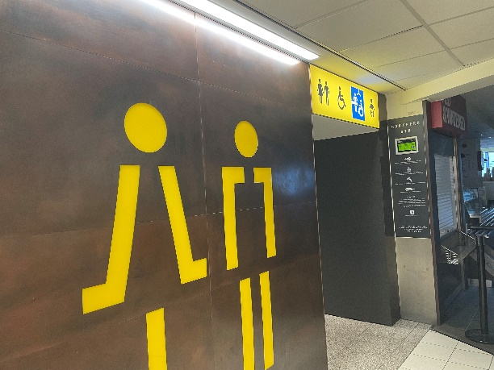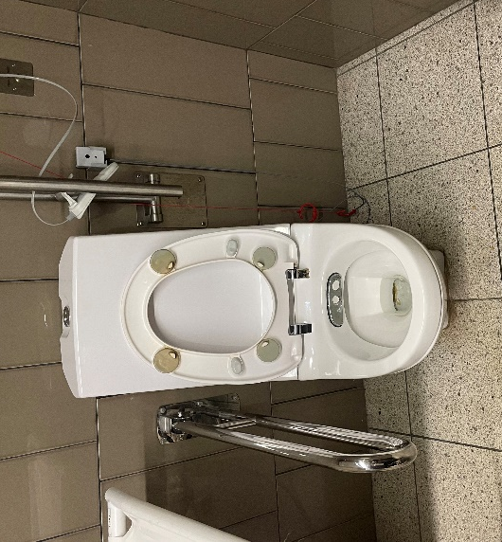
Figure 18: Changing Places toilet Figure 19: Inside Changing Places toilet
Recommendations:
- Provide more signage throughout the departures area indicating location of Changing Places toilet.
- Provide bigger signage at the entrance to the toilet indicating that it is Changing Places – including text.
- Provide braille signage to Changing Places toilet.
4.26 The main toilets in this area had similar issues to those in the departures area. The corridor leading to the cubicles was very dark – one participant commented that it was “like a tunnel” (Figure 20).
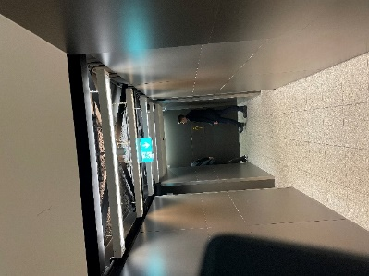
Figure 20: Corridor to toilets in departure lounge at bar area
Recommendation:
- Provide signage/arrows at eye level along corridor to the toilets.
4.27 A “quiet area” is available before the international departures lounge. Participant feedback was positive - the area had lots of natural light and was very relaxed and quiet, with signs and information on walls at an absolute minimum. However it was felt that the signage for this space needed to be bigger and more visible (Figure 21) and that its availability should be promoted elsewhere in the airport. Airport staff noted that the seating in the special assistance area was being refurbished and would be resprayed to a “more obvious” colour. Participants advised that this should be in more contrasting colours.
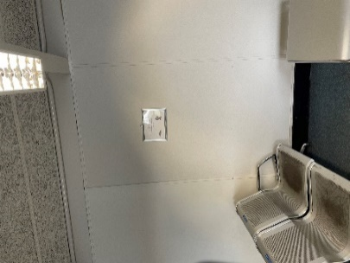
Figure 21: Quiet area
Recommendations:
- Increase size of signage in quiet area.
- Highlight the availability of the quiet area elsewhere in the airport and on the airport website.
- When undertaking refurbishment of the PRM seating in this area ensure they are in contrasting colours and so can be defined more easily.
4.28 Passengers need to go through the main departures lounge to get to the quiet area. Participants were keen that this facility would be available at an earlier stage e.g. after the security checks, so that those who wanted to could avoid undue noise. Staff noted that a decompression zone in the departures area was planned as part of the redevelopment of the airport.
International Departure Lounge
4.29 Participants commended the availability of free drinking water stations both here and at other gates within the airport. They also noted the availability of an airbridge to planes from this lounge.
4.30 The signs to the toilets within the international departure lounge were thought to be clearer than those elsewhere in the airport, and at eye level (Figure 22). The disabled toilet had very tight entry for even a small wheelchair (Figure 23); however the blue handles provided a good contrast to the seat (Figure 24). It was also noted that there was a handle to flush the disabled toilet rather than a push button, which is considered preferable. A rubbish bin was positioned by the door; this could prove difficult for a wheelchair user to navigate around.
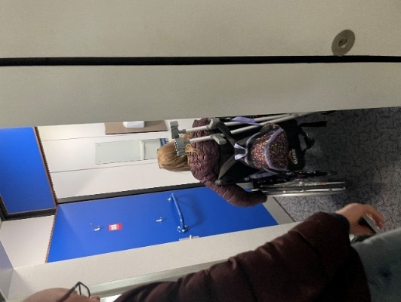
Figure 22: International departures toilet Figure 23: Disabled toilet entry
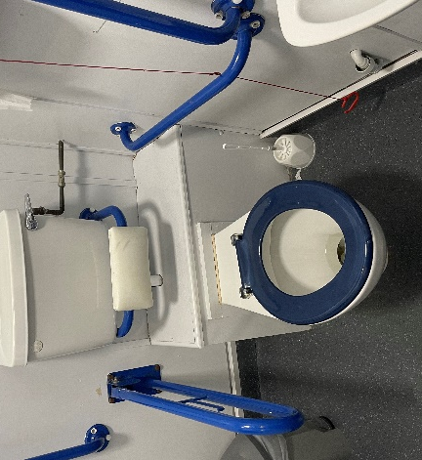
Figure 24: Contrasting handles in disabled toilet
Recommendations:
- Consider replicating signage for these toilets for others across the airport.
- Investigate configuration of disabled toilet to ensure it meets specifications for wheelchair users.
- Consider replicating the blue contrasting handles in other toilets across the airport.
- Consider placement of bins in toilet areas across the airport to ensure they are not in the way of users.
Arrivals – Border Control
4.31 There were a lot of signs and information in the border control area which made the space seem quite busy and overwhelming. A suggestion was made to have additional toilets in this area; although airport staff stated that anyone requiring special assistance could avail of priority queuing in this area and thus exit to the arrivals hall quickly.
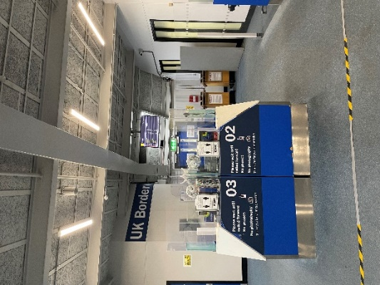
Figure 25: Border Control
Recommendations:
- Review signage in this area.
4.32 There is a lift down to baggage reclaim, however the signage for this is at ceiling level (Figure 26). The width of the opened lift doors was just wide enough for a standard wheelchair but would be too narrow for a wider one. There is also a risk that the lift operator could catch their knuckles on the edge of the doors (Figure 27). The escalator could also avail of a contrasting colour at the top and bottom.
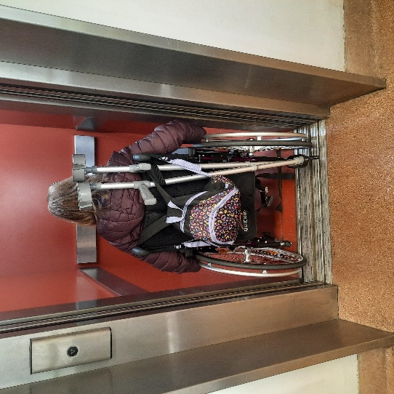
Figure 26: Lift signage Figure 27: Lift to baggage reclaim
Recommendations:
- Provide signage at eye level to lift down to baggage reclaim.
- Provide additional signage e.g. arrows along the corridor indicating the exact location of the lift.
- Provide yellow paint at top and bottom of escalator.
Baggage reclaim area
4.33 Participants commented positively on the facilities available in the baggage reclaim area, including showers and family restrooms. The disabled toilet facilities were felt to be superior here than in other areas of the airport. Signage to the toilet area was also praised as being of adequate size and of a good contrast (Figure 28). Signage elsewhere in the baggage reclaim area was on a sloped ceiling (Figure 29) which was felt to be quite high and would ideally be at eye level. However, it was appreciated that this would be useful when the area was particularly busy.
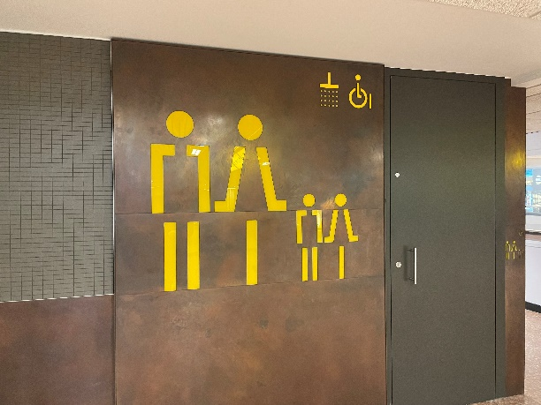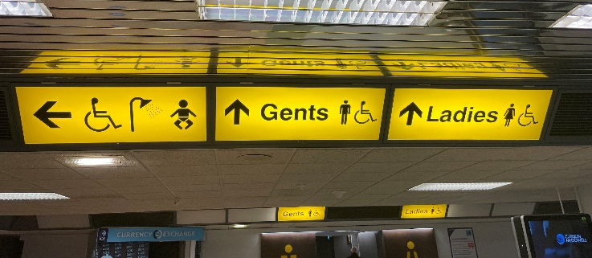
Figure 28: Toilets in baggage reclaim Figure 29: Signage in baggage reclaim area
Domestic Arrivals area
4.34 In general the signage was the “new” version referred to in paragraph 4.22 with a black/grey on blue and lime green/dark brown contrasting colour, which was not ideal (Figures 30 and 31). Although it was a decision that was not taken by Belfast International Airport staff, participants reiterated the importance of involving relevant groups in decision making at an early stage so that potential issues could be raised during the planning process and indicated a strong desire that this be reviewed.
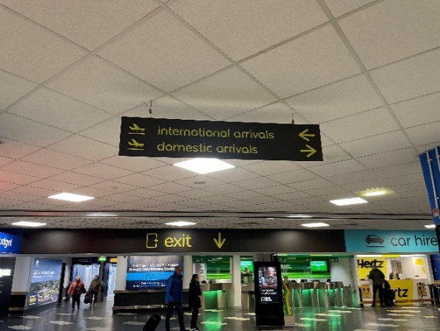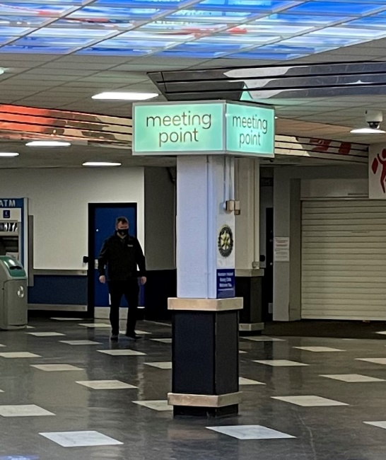
Figure 30: Arrivals signage Figure 31: Meeting point signage
4.35 There was no signage to indicate that a ramp was available to the café entrance in the arrivals area (Figure 32). It was also felt that the car hire counters (Figure 33) and currency exchange machine were very high and inaccessible to anyone in a wheelchair.
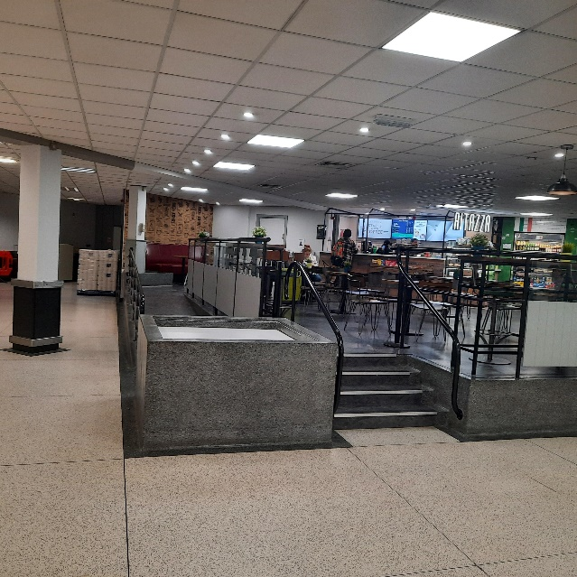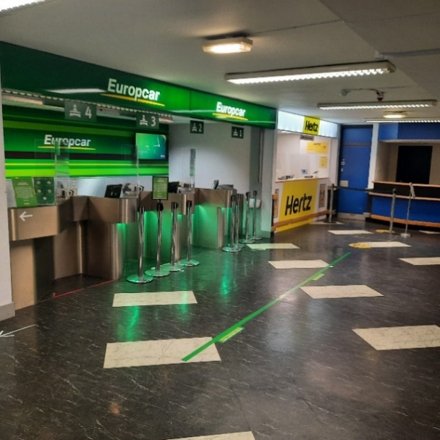
Figure 32: Café in arrivals hall Figure 33: Car hire counters
Recommendation:
- Liaise with third party delivery partners to conduct an accessibility audit of their facilities.
4.36 A “Quiet Room” is available in the arrivals hall. Participants thought this was useful but passengers would benefit from a similar facility in the departures area. Access to the room is via a ramped passage containing narrow tight corners which was very difficult for wheelchair users to navigate (Figure 34).
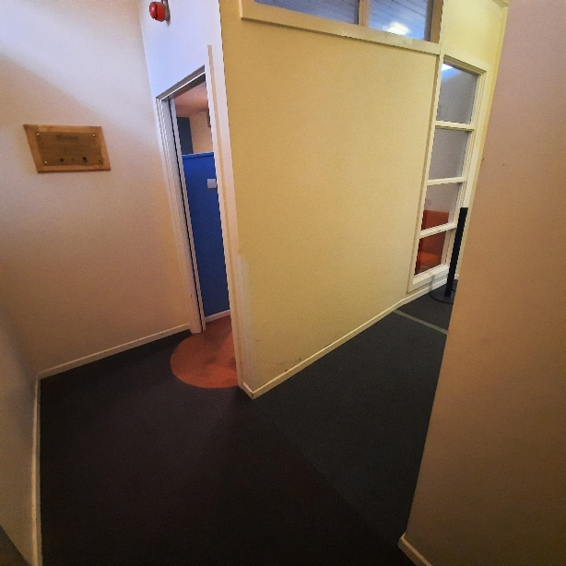
Figure 34: Quiet Room
Recommendation:
- Consider redesign of the Quiet Room as part of the overall renovations, in order to better facilitate wheelchair users.
Leaving the airport
4.37 It was noted that the tactile paving across from the arrivals hall was a mixture of colours – it was suggested that this should all be red as it is a controlled crossing (Figure 35). This would aid mobility, particularly for visually impaired people.
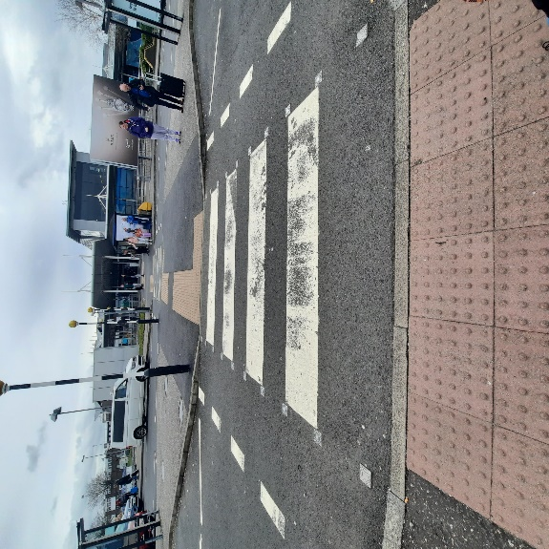
Figure 35: Crossing from arrivals hall
Recommendation:
- Investigate specifications for the use of tactile paving surfaces and upgrade paving accordingly.
4.38 Participants noted the infrequency of Translink services from the airport to destinations outside of Belfast; as well as the lack of electronic signage, either inside the Arrivals hall or at the halt, stating times of next buses. The Consumer Council will follow these points up with Translink.

5. CONCLUSIONS

5.1 Participants welcomed the opportunity to tour the airport and expressed satisfaction throughout at the processes and changes that had been implemented already to improve the experience for passengers requiring special assistance. Participants were able to ask questions throughout the visit and make suggestions based on their experiences and knowledge of some of the barriers passengers may face. A number of suggestions were made around signage, flight display boards, the need for more contrasting colours on escalators and steps, wheelchair access and toilet facilities.

5.2 The airport is currently being redesigned/renovated. It will be important to liaise with the Airport Accessibility Forum and other groups at this design stage to ensure the new facilities are accessible to all. This should include, for example, investigating the possibility of adding additional changing places toilets.

6. NEXT STEPS

6.1 The comments made by participants will be presented to the airport through this report. The Consumer Council will work with the airport as it implements the changes to ensure that services continue to meet passengers’ needs. An update on the progress made against the suggestions will be shared with the Airport’s Accessibility Forum at its next meeting.

Annex 1 Summary of Recommendations

 | Signage
1 | Provide additional signage at entry to short stay car park with directions to disabled parking bays.
2 | Make signage clearer around the accessible drop off areas to deter other vehicles from stopping there.
3 | Increase size of signage to reserved seating in the check-in area.
4 | Provide additional signage e.g. arrows at eye level in toilet corridors.
5 | Provide signage in check-in area and at earlier points in departures to indicate presence of changing places toilet beside Gate 19.
6 | Provide braille/”not every disability is visible” signage at disabled toilet in check-in area.
7 | Make signage indicating priority/special assistance lane larger.
8 | Add signage beside flight departure screen at security indicating that larger screens are available elsewhere in the airport.
9 | Add additional textual “toilet” signage in addition to figures.
10 | Provide additional signage in main toilet areas to distinguish cubicles.
11 | Provide additional signage for hand dryers.
12 | Improve signage on reserved seating area immediately after restaurants e.g. mark in yellow to differentiate. When undertaking refurbishment of PRM seating ensure they are in contrasting colours and so can be defined more easily.
13 | Provide additional directional signage to gates at eye level where possible and/or on floor where this is possible.
14 | Brown/green colouring on signage is problematic for accessibility purposes as it is more difficult to perceive information than other backgrounds e.g. black on yellow. This should be raised with the airport owners.
15 | Make signage indicating Gate 10 (and similar gates across the airport where applicable) larger.
16 | Review size of flight information screens across the airport and consider increasing.
17 | Provide bigger signage at the entrance to the Changing Places toilet indicating that it has that facility – including text.
18 | Provide braille signage to Changing Places toilet.
19 | Consider replicating signage at toilets at international departures in other toilets across the airport.
20 | Increase size of signage in quiet area.
21 | Highlight the availability of the quiet area elsewhere in the airport and on the airport website.
22 | Review signage in border control area to ensure it is not over “busy”.
23 | Provide signage at eye level to lift down to baggage reclaim.
24 | Provide additional signage e.g. arrows along the corridor indicating the exact location of the lift.
 | Parking/Drop off areas
25 | Review the size of disabled parking bays and consider expanding beyond the regulation standard if possible.
26 | Ensure that the five stage process for booking car parking is easily accessible on the airport website.
27 | Provide additional information at pay stations so that passengers know they can avail of special assistance for parking.
28 | Give consideration to increasing the amount of disabled parking bays in the coach park.
 | Toilet Facilities
29 | Investigate possibility of installing an additional changing places toilet at check in area.
30 | Investigate design of disabled toilet in check in area i.e. could more room be provided for wheelchair users.
31 | Investigate whether push button flush could be replaced with a handle.
32 | Check configuration of disabled toilet at restaurant area after check-in to ensure there is enough space for wheelchairs.
33 | Consider installing automatic “toilet protectors” in the disabled toilets to ensure users can easily disinfect the seat.
34 | Consider replicating the blue contrasting handles in disabled toilet at international departures in other toilets across the airport.
35 | Consider placement of bins in toilet areas across the airport to ensure they are not in the way of users.
 | Escalators/Steps
36 | Provide yellow paint at top and bottom of all escalators/steps across the airport.
 | Security area
37 | Mark out priority queue clearly with one, contrasting colour for the poles and ropes e.g. yellow or blue.
38 | Replace carpeted areas in the private search/interview room and in other areas of the airport with tiled/smooth flooring where possible.
 | Flight Information screens
39 | Review size of flight information screens across the airport and consider increasing.
 | Restaurant/car hire services in arrivals hall
40 | Liaise with third party delivery partners to conduct an accessibility audit of their facilities.
 | Quiet Room
41 | Consider redesign of the Quiet Room as part of the overall renovations, in order to better facilitate wheelchair users.
 | Pavements outside airport
42 | Investigate specifications for the use of tactile paving surfaces and upgrade paving accordingly.
 | Future Airport Expansion
43 | Liaise with the Airport Accessibility Forum and other groups at the design stage to ensure the new facilities are accessible to all.

European Regulation (EC) 1107/2006
People of Restricted Mobility (PRM)
Regulation (EC) No 1107/2006 (as amended by The Air Passenger Rights and Air Travel Organisers’ Licencing (Amendment) (EU Exit) Regulations 2019)
Civil Aviation (Access to Air Travel for Disabled Persons and Persons with Reduced Mobility) Regulations 2007 (SI 2007/1895)
IMTAC, Alzheimer’s Society, Autism NI, Crohns and Colitis UK, Guide Dogs for the Blind Association, Royal National Institute of Blind People, Royal National Institute for Deaf People (RNID)

